2HandBook

**Software Development Plan**

**Version 1.**1

**Revision History**

| **Date** | **Version** | **Description** | **Author** |
| --- | --- | --- | --- |
| 25/06/2023 | 1.0 | Initial Software Development Plan | All members of “Code999+Bugs” |
| 16/07/2023 | 1.1 | Update 4.2 of Project plan for PA2 | Binh Nguyen Thanh |
|  |  |  |  |
|  |  |  |  |

**Table of Contents**

**1. Introduction 4**

1.1 Purpose 4

1.2 Scope 4

1.3 Overview 4

2. Project Overview 4

2.1 Project Purpose, Scope, and Objectives 4

2.2 Assumptions and Constraints 4

2.3 Project Deliverables 6

3. Project Organization 6

3.1 Organizational Structure 6

3.2 Roles and Responsibilities 6

4. Management Process 7

4.1 Project Estimates 7

4.2 Project Plan 7

4.2.1 Sprint 0 - PA0 7

4.2.2 Sprint 1 - PA1 7

4.2.3 Sprint 2 - PA2 8

4.2.4 Sprint 3 - PA3 9

4.2.5 Sprint 4 - PA4 9

4.2.6 Sprint 5 - PA5 10

4.3 Project Monitoring and Control 10

4.3.1 Requirements Management 10

4.3.2 Reporting and Measurement 10

4.3.3 Risk Management 11

4.3.4 Configuration Management 12

**Software Development Plan**

# Introduction

The introduction of the **Software Development Plan** provides an overview of the entire document. It includes the purpose, scope, definitions, acronyms, abbreviations, references, and overview of this **Software Development Plan**.

## **Purpose**

The purpose of the **Software Development Plan** is to gather all information necessary to control the project. It describes the approach to the development of the software and is the top-level plan generated and used by managers to direct the development effort.

The following people use the **Software Development Plan**:

* The **project manager** uses it to plan the project schedule and resource needs, and to track progress against the schedule.
* **Project team members** use it to understand what they need to do, when they need to do it, and what other activities they are dependent upon.

## **Scope**

This **Software Development Plan** describes the overall plan to be used by the 2HandBook project, including deployment of the product. The details of the individual iterations will be described in the Iteration Plans.  
The plans as outlined in this document are based upon the product requirements as defined in the **Vision Document.**

## **Overview**

This **Software Development Plan** contains the following information:

Project Overview — provides a description of the project's purpose, scope, and objectives.  It also defines the deliverables that the project is expected to deliver.

Project Organization — describes the organizational structure of the project team.

# Project Overview

## **Project Purpose, Scope, and Objectives**

After studying a course, students tend to throw away books while there are still many people who need them. Therefore, we aim to reach both those who have old books that they no longer need and those who need these books. We would like to launch a website named 2HandBook, which will help students to easily buy and sell old books.

## **Assumptions and Constraints**

| **Actor** | **Feature** | **Time** | **Expense** |
| --- | --- | --- | --- |
| All actors | Log in | 1 hours | 100.000đ |
| Sign up | 1 hours | 100.000đ |
| Admin | Approve accounts | 2 hours | 200.000đ |
| Delete or suspend accounts | 2 hours | 200.000đ |
| Send notifications | 3 hours | 300.000đ |
| Pick a handful of popular products to put in the Trending section | 3 hours | 300.000đ |
| Information about all seller accounts and buyer accounts. | 4 hours | 400.000đ |
| Seller | Post, view, update and delete their product information | 2 hours | 200.000đ |
| Manage list of orders. | 3 hours | 300.000đ |
| View list of followers. | 3 hours | 300.000đ |
| Respond to customer feedback | 2 hours | 200.000đ |
| View statistical information | 4 hours | 400.000đ |
| Create, view, update and delete discount vouchers | 2 hours | 200.000đ |
| Buyer | Search products | 2 hours | 200.000đ |
| Filter products | 1.5 hours | 150.000đ |
| Sort products | 3 hours | 300.000đ |
| Add to cart | 3 hours | 300.000đ |
| Edit purchase quantity | 2 hours | 200.000đ |
| Buy products, cancel orders, view current orders | 2 hours | 200.000đ |
| Report products, violation of standards | 3 hours | 300.000đ |
| Watch purchase history, the total expense of months or years | 5 hours | 500.000đ |
| **Total expense: 5.350.000đ** | | | |

## **Project Deliverables**

Deliverables for this project is a website and attached documents. Deliverables are delivered towards the end of the iteration, as specified in section 4.2.4 Project Schedule

# **Project Organization**

## **Organizational Structure**

## 

## **Roles and Responsibilities**

| **Person** | **Role** |
| --- | --- |
| Tra Hoang Anh, Project Manager | Project Manager: allocates resources, shapes priorities, establishes a set of practices that ensure the integrity and quality of project artifacts.  Full Stack Developer: builds and maintains both the front-end and the back-end of the website.  Data Engineer: refers to the building of systems to enable the collection and usage of data.  Tester: involves conducting the necessary tests and logging the outcomes of that testing. |
| Tuan Nguyen Duc, Front-end Developer | Front-end Developer: creates the look of websites and web applications.  Data Engineer: refers to the building of systems to enable the collection and usage of data.  Tester: involves conducting the necessary tests and logging the outcomes of that testing. |
| Trieu Dinh Quy, Front-end Developer | Front-end Developer: creates the look of websites and web applications.  Data Engineer: refers to the building of systems to enable the collection and usage of data.  Tester: involves conducting the necessary tests and logging the outcomes of that testing. |
| Binh Nguyen Thanh, Full Stack Developer | Full Stack Developer: builds and maintains both the front-end and the back-end of the website.  Data Engineer: refers to the building of systems to enable the collection and usage of data.  Tester: involves conducting the necessary tests and logging the outcomes of that testing. |
| Hai Tran Phuc, Test Manager | Test Manager: defines and manages the test approach and ensures its successful implementation.  Back-end Developer: develops and tests components, in accordance with the project’s adopted standards.  Data Engineer: refers to the building of systems to enable the collection and usage of data. |

# **Management Process**

## **Project Estimates**

## **Project Plan**

### **Sprint 0 - PA0**

Duration: 2 weeks

Time: 29/05/2023 - 11/06/2023

Gantt chart:

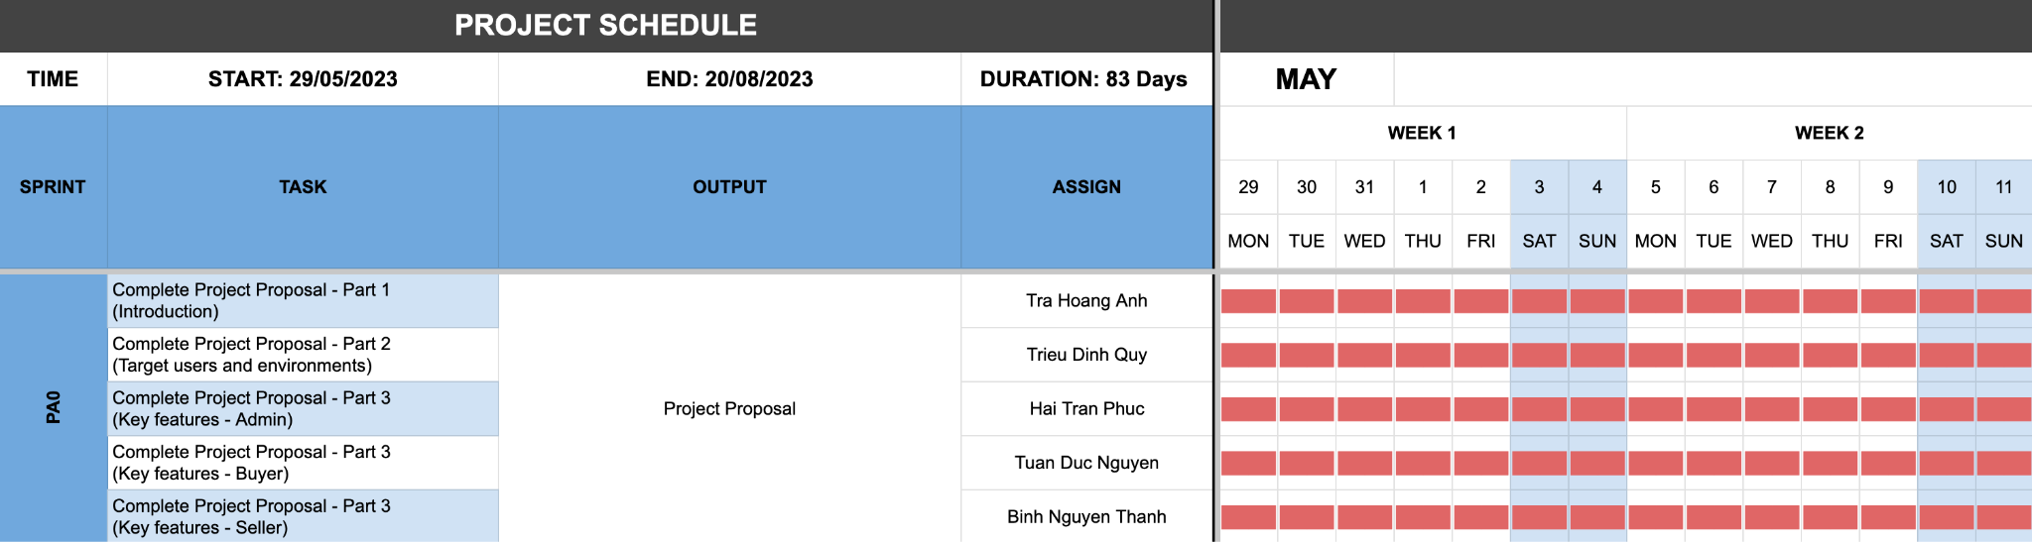

### Sprint 1 - PA1

Duration: 2 weeks

Time: 12/06/2023 - 25/06/2023

Gantt chart:

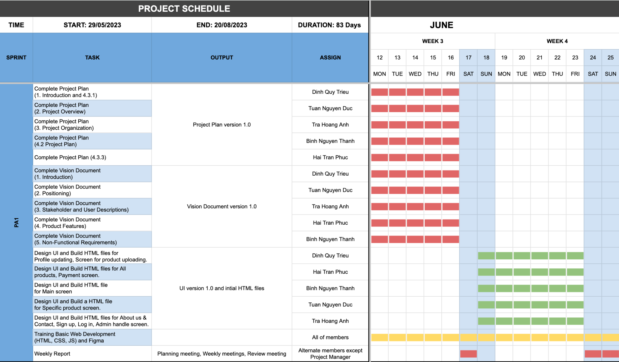

### 

### **Sprint 2 - PA2**

Duration: 2 weeks

Time: 03/07/2023 - 16/07/2023

Gantt chart:

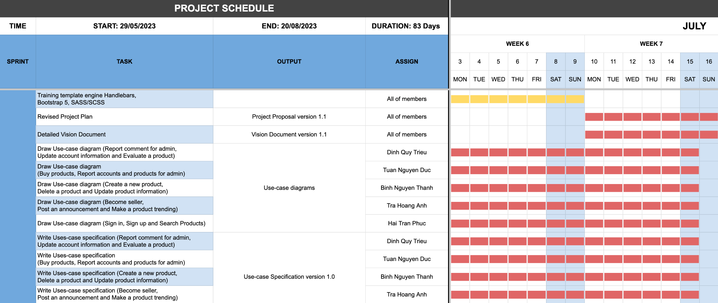

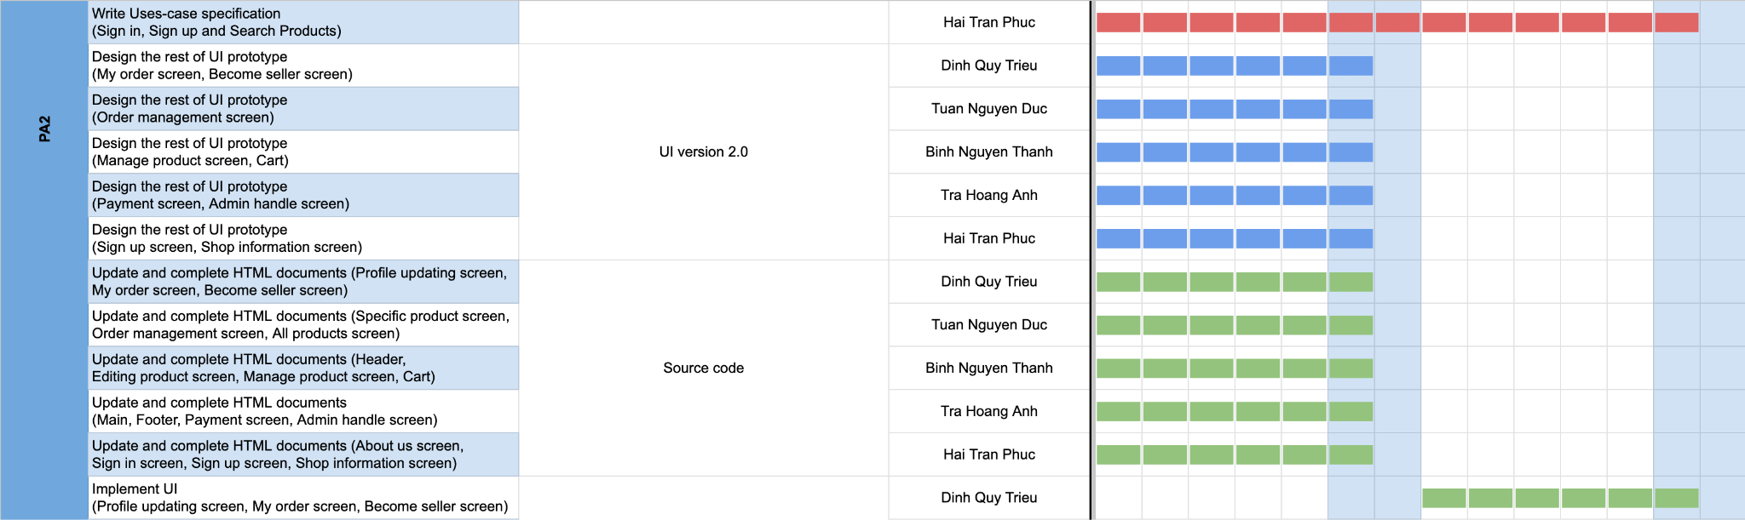

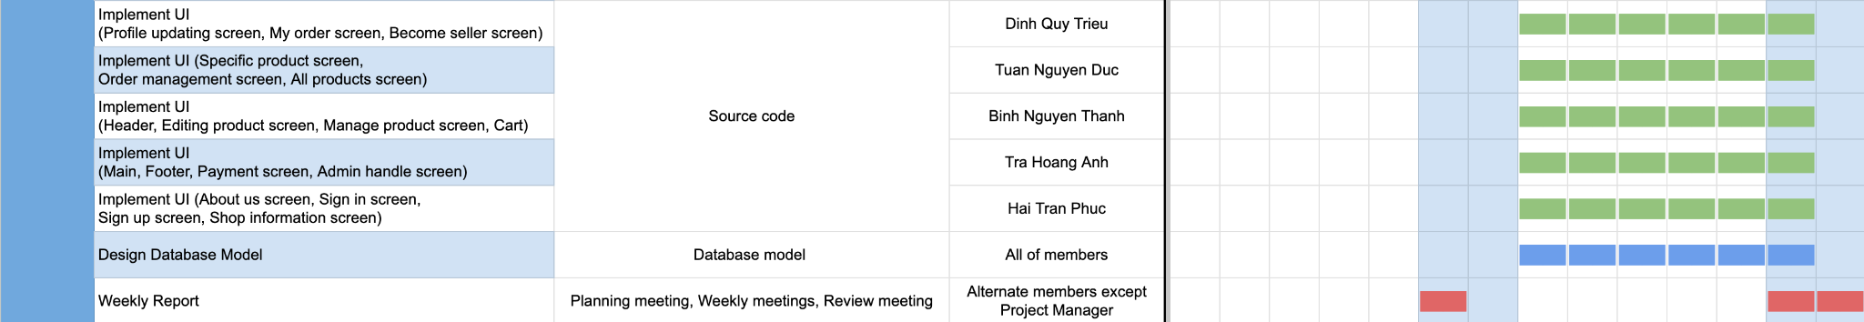

### *Sprint 3 - PA3*

Duration: 2 weeks

Time: 17/07/2023 - 30/07/2023

Gantt chart:

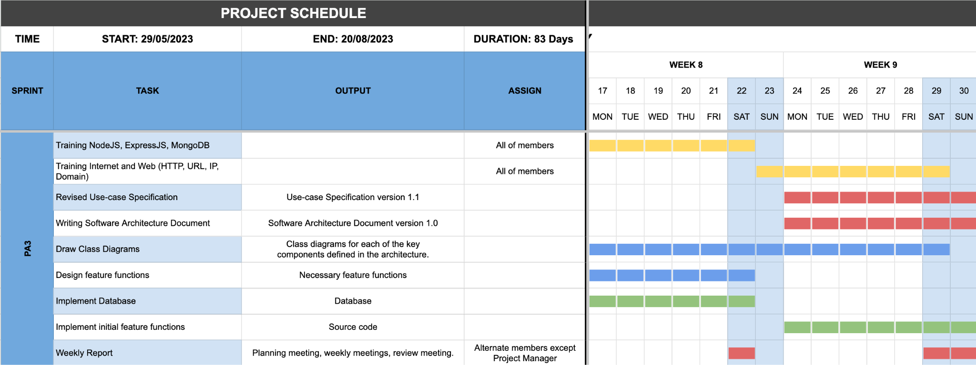

### **Sprint 4 - PA4**

Duration: 2 weeks

Time: 31/07/2023 - 13/08/2023

Gantt chart:

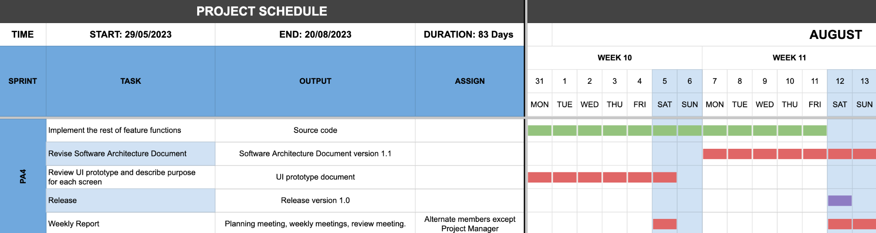

### Sprint 5 - PA5

Duration: 2 weeks

Time: 14/08/2023 - 27/08/2023

Gantt chart: 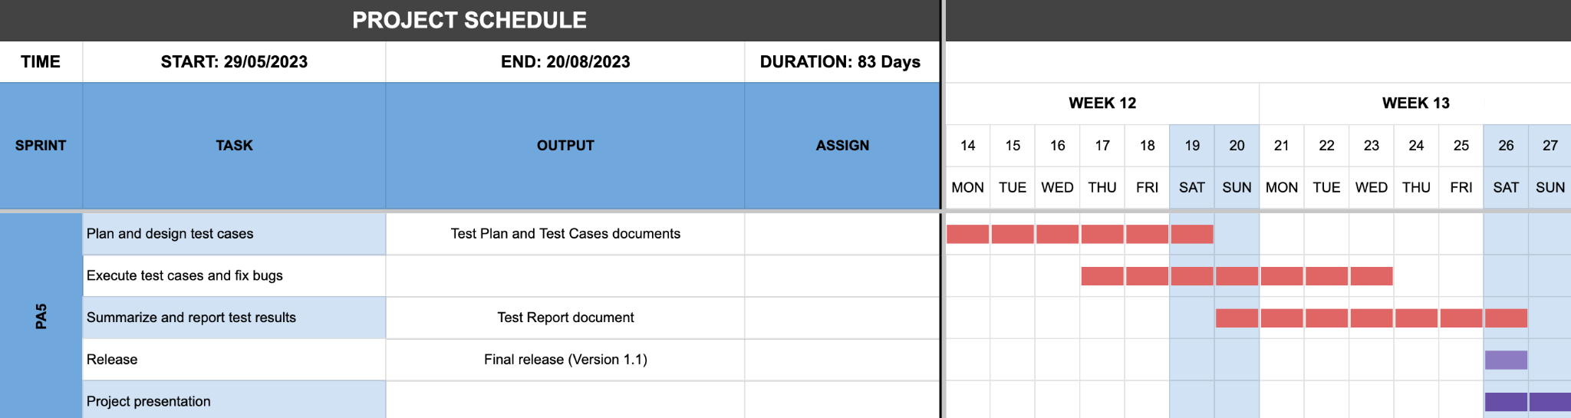

## **Project Monitoring and Control**

### Requirements Management

The requirements for this system are captured in the Vision document. Requested changes to requirements are captured in Change Requests, and are approved as part of the Configuration Management process.

### Reporting and Measurement

Updated cost and schedule estimates, and metrics summary reports, will be generated at the end of each iteration.

The Minimal Set of Metrics, as described in the RUP Guidelines: Metrics, will be gathered on a weekly basis. These include:

Earned value for completed tasks. This is used to re-estimate the schedule and budget for the remainder of the project, and/or to identify need for scope changes.

Total defects open and closed – shown as a trend graph. This is used to help estimate the effort remaining to correct defects.

Acceptance test cases passing – shown as a trend graph. This is used to demonstrate progress to stakeholders.

In addition, overall costs will be monitored against the project budget.

### Risk Management

Risks will be identified in Inception Phase using the steps identified in the RUP for Small Projects activity “Identify and Assess Risks”. Project risk is evaluated at least once per iteration and documented in this table. The risks of the greatest magnitude are listed first in the table.

| **Risk Ranking (High, Medium, Low)** | **Risk Description and Impact** | **Mitigation Strategy and/or Contingency Plan** |
| --- | --- | --- |
| High | Lack of commitment from team members due to personal reasons or pressure from other subjects of the semester which affects time spent on this project. | The team should provide a supportive environment so that any member when faced with difficulties will be more willing to address the problems so that the team can find a solution together. |
| High | Not fully understanding the requirements of documentation which can lead to omissions of some required information. | Read the requirement descriptions carefully and regularly exchange with the TAs if there are any questions or further updates. |
| High | Unreasonable assignment of tasks due to underestimation of the time needed. This can affect members’ confidence. Some members can be assigned too much, while the others have little to do. | To solve this problem require planning abilities from the team, especially the team leader. Every member should feedback regularly if they find the tasks too hard, so that the team can rebalance the tasks or manpower reasonably. |
| Medium | Some features in proposal are not practical enough to be implemented, which can lead to dead ends and waste of time | Team should regularly monitor the feasibility of certain features to avoid spending excessive time on unrealistic features. |
| Medium | Lack of cooperation or team quarrels. This affects team morale and group productivity. In extreme cases, members can decide to leave the team, or commit poorly to the project. | Team members should socialize with each other through bonding activities, eating out, chatting to be more understanding and cooperative. This will increase productivity and ease of communication. |
| Medium | Conflicts when merging code that lead to errors when running the whole website, or difficulties in developing and maintaining the website, due to lack of uniform coding. | Plan beforehand to agree on code outline, naming conventions, library usage, which increase code cohesion and decrease the chance of incompatibility. |
| Medium | Lack of coding experience in the necessary programming languages, tools. It can create low-quality features or website as a whole. The programs can even not able to run at all. | Every member should study the languages on their own, as well as hosting regular code meetings so that every member can share what they have learnt, and what they find difficult that possibly requires explaining from a team member who is more knowledgeable in that area.  Ready to compromise if there is a feature that requires programming ability way above that of the team. |
| Low | Difficulties in designing interfaces. Users of the website can find it hard to navigate, or find it unappealing and less willing to use the platform. | Ask for regular feedback from other team members to improve, sign up for basic courses about color usage, website layout, animations, etc. |

### Configuration Management

Appropriate tools will be selected which provide a database of Change Requests and a controlled versioned repository of project artifacts.

All source code, test scripts, and data files are included in baselines. Documentation related to the source code is also included in the baseline, such as design documentation. All customer deliverable artifacts are included in the final baseline of the iteration, including executables.